**Chime Audiology are Specialist hearing experts who run weekly clinics at The Hub.** They are a not-for-profit Community Interest Company contracted by the NHS to offer adult and children’s audiology services across in Exeter, Mid & East Devon.

Chime take GP referrals for hearing tests with both adults and children. Hearing tests are quick, accurate, personalised assessments, which are usually completed within 15-30 minutes by an experienced audiologist. Results and a way forward are discussed following assessment.

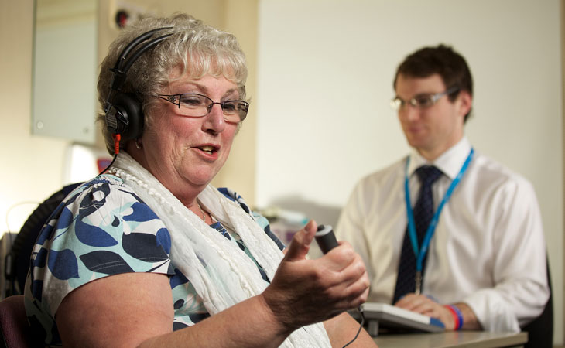

Chime also offer an earwax removal service.

For further information you may call 01392 402223 or visit <https://www.chimehealth.co.uk/>